**Document containing the screenshots from Part 1 and Part 2, along with description of the steps:-**

**Part 1**

To install the latest version of Laravel using Composer and verify its installation, follow these steps:

Step 1: Install Composer

If you don't have Composer installed on your system, follow the official documentation to install it: https://getcomposer.org/download/

Step 2: Open Terminal/Command Prompt

Open your terminal or command prompt. Ensure you have internet connectivity.

Step 3: Create a new Laravel project

In the terminal, navigate to the directory where you want to create your Laravel project. Then, run the following command to create a new Laravel project named "mainulhassan":

composer create-project laravel/laravel mainulhassan

Step 4: Open the folder with VSCODE and open new terminal .Verify Laravel installation Once the project creation is complete, navigate to the "mainulhassan" directory using the following command:

cd mainulhassan

Step 5: Run the development server To start the development server, run the following command:

php artisan serve

This will start the development server at http://127.0.0.1:8000/.

Step 6: Verify Laravel installation

Open your web browser and navigate to http://127.0.0.1:8000/. If Laravel is installed correctly, you should see the default Laravel welcome page.

Step 7: Take a screenshot

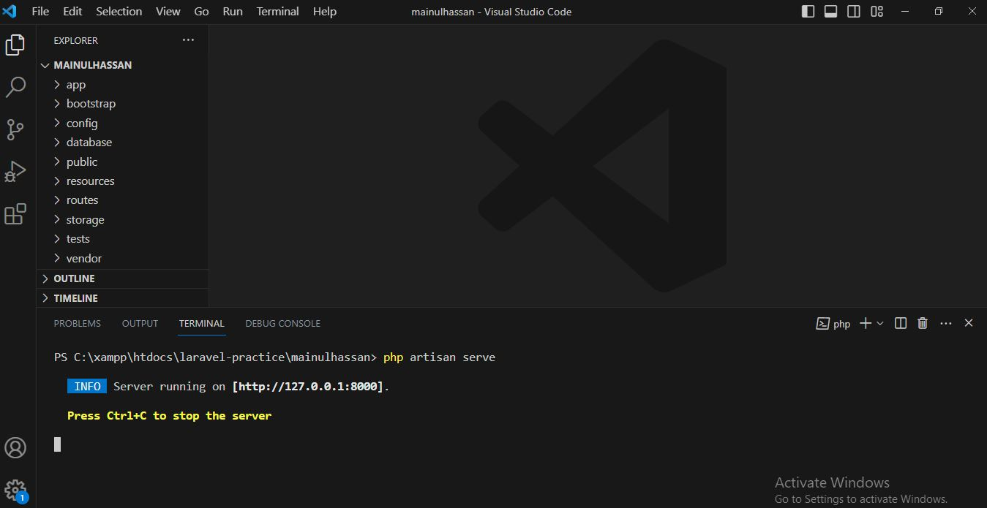

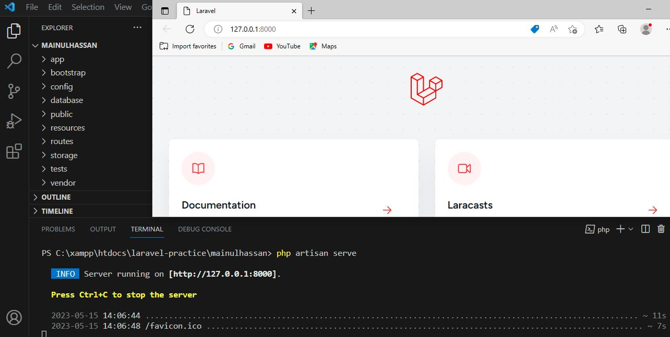

Take a screenshot of the running Laravel development server for documentation purposes.

Please note that Laravel requires PHP and some additional extensions to be installed on your system. Ensure that you have PHP installed and configured correctly before proceeding with these steps.

After following these steps, you should have the latest version of Laravel installed and running the development server successfully. Remember to take a screenshot of the running server for documentation purposes.

**Part 2**

Create a new route in your Laravel project that displays a simple "Hello, World!" message. Take a screenshot of the running route.

Step 1: Define the route

Open the routes/web.php file and add the following code to define a new route:

Route::get('/hello', function () {

return 'Hello, World!';

});

This code defines a GET route at the /hello URL path that returns the "Hello, World!" message.

Step 3: Save the changes

Save the routes/web.php file after adding the route.

Step 4: Run the development server

If the development server is not already running, start it by running the following command

in the project directory:

php artisan serve

Step 5: Access the route

Open your web browser and navigate to http://127.0.0.1:8000/hello. You should see the "Hello, World!" message displayed.

Step 6: Take a screenshot

Take a screenshot of the running route that displays the "Hello, World!" message for documentation purposes.

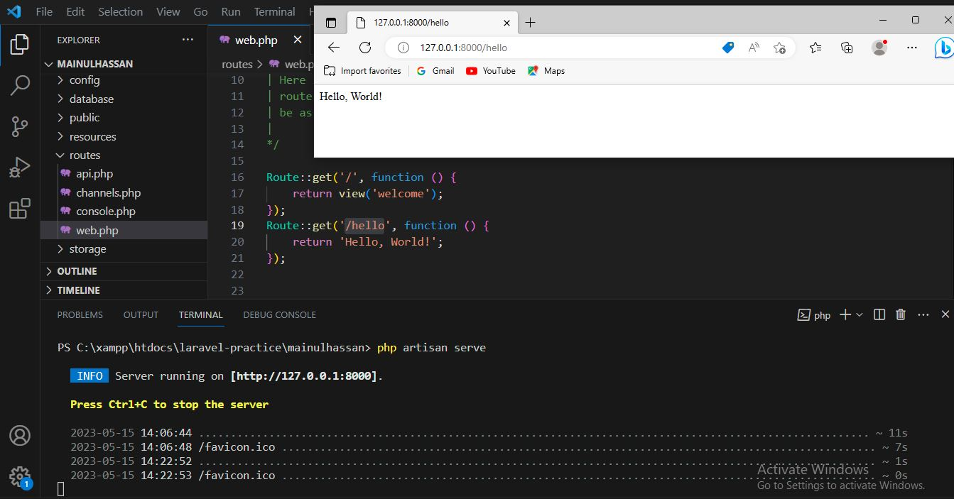

By following these steps, we can create a new route in our Laravel project that displays a simple "Hello, World!" message. Remember to take a screenshot of the running route for documentation purposes.